**Sean Chambers & the Savoy Brown Rhythm Section – 5/21**

May 21 @ 7:00 pm - 9:00 pm

**$30 – $40**

We’re thrilled to welcome **SEAN CHAMBERS & THE SAVOY BROWN RHYTHM SECTION** back to the 443 for a two-night run on May 21 & 22.

Florida-born **SEAN CHAMBERS** began his career in the Blues back in 1998 when he toured with the legendary Hubert Sumlin as his guitarist and band leader until 2003. During Sean’s tenure with Mr. Sumlin, Britain’s Guitarist magazine named Chambers as “One of the top 50 blues guitarists of the last century.”

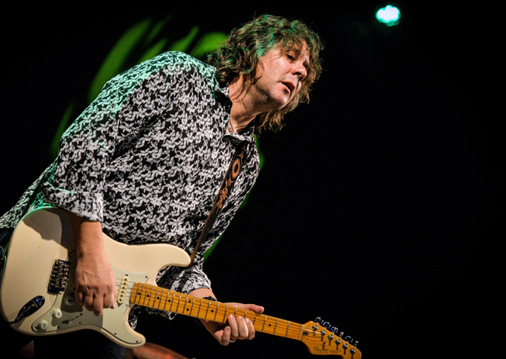

Sean’s albums are critically acclaimed, charted on Billboard Blues, and nominated for awards by Canada’s Underground Blues Network, the Jimi Awards, and the Blues Blast Music Awards.

On March 1st, 2020, Chambers went into the studio and recorded his 8th album entitled “That’s What I’m Talkin’ About”, a tribute to his mentor the late great Hubert Sumlin. The album reached the Top Ten on the Billboard Blues Charts and received accolades and rave reviews around the globe.

**“It’s great to see an unsung guitar legend the caliber of Hubert Sumlin, who played with Muddy Waters and Howlin’ Wolf, being celebrated by a young artist Sean Chambers. Hubert was bending strings before anyone!” – Paul Rodgers (Bad Company) – (Jul 09, 2021)**

In 2023, shortly after the unfortunate passing of Savoy Brown’s founder & leader, “Kim Simmonds”, Chambers teamed up with the Savoy Brown rhythm section, Pat De Salvo on Bass, and Garnet Grimm on drums. Chambers and the members of Savoy Brown became friends after playing a festival together in 2019. Savoy Brown and Sean Chambers are on the same record label, so the change made sense and felt right to all three musicians.